EXPERIMENT NO : 5

NAME : SAHIL TRIPATHI

AIM : Write a Verilog code for the implementation of 4 bit full adder using instance of 1 bit full adder.

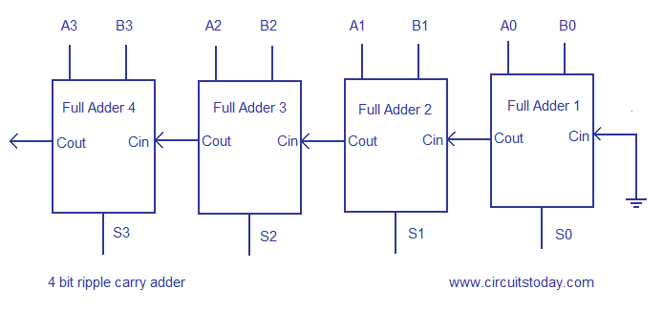

TRUTH TABLE

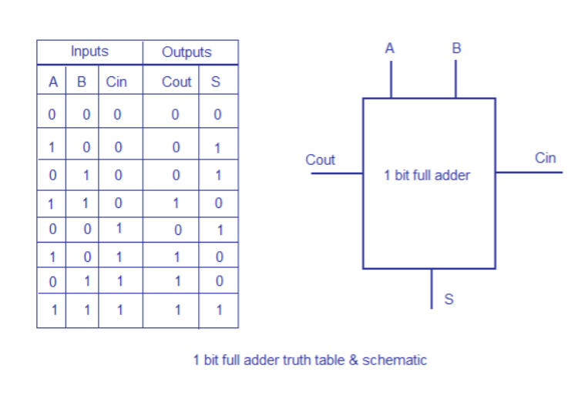

CODE FOR HALF ADDER (FOR RIPPLE CARRY ADDER)-

module fullAdder ( In1,In2,Cin,Sum,Cout);

input In1,In2,Cin;

output Sum, Cout;

assign Sum = (In1 ^ In2) ^ Cin;

assign Cout = (In1 & In2) | (In2 & Cin) | (Cin & In1);

endmodule

IMAGE OF CODE –

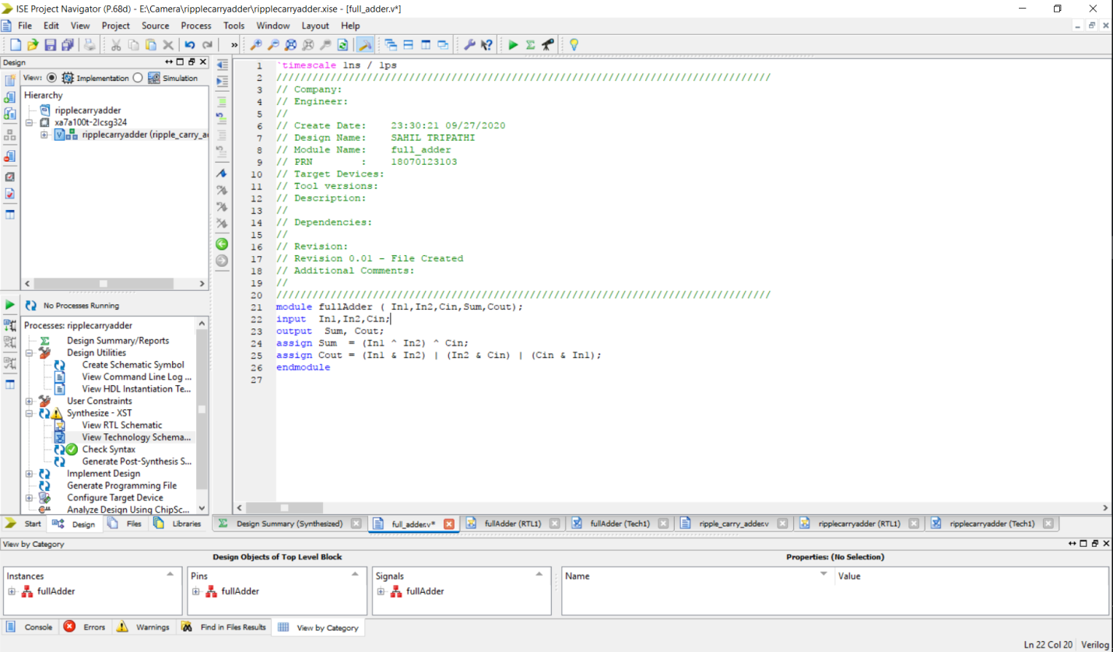

RIPPLE CARRY ADDER

module ripplecarryadder(A,B,S,Cout);

input [3:0] A,B; // imitialize the size of input and output

output [3:0] S;

output Cout;

wire W1,W2,W3;

fullAdder u1(A[0],B[0],1'b0,S[0],W1); // 1-fulladder bit adder

fullAdder u2(A[1],B[1],W1,S[1],W2);

fullAdder u3(A[2],B[2],W2,S[2],W3);

fullAdder u4(A[3],B[3],W3,S[3],Cout);

endmodule

IMAGE OF CODE –

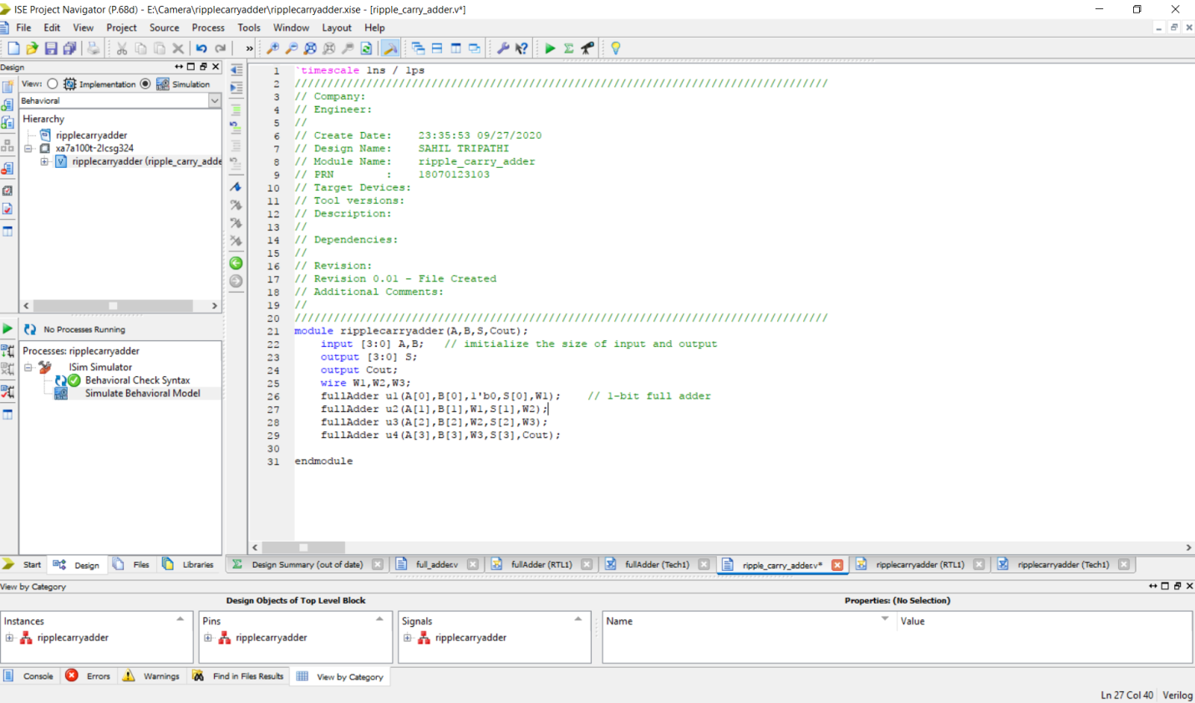

RTL OF RIPPLE CARRY ADDER

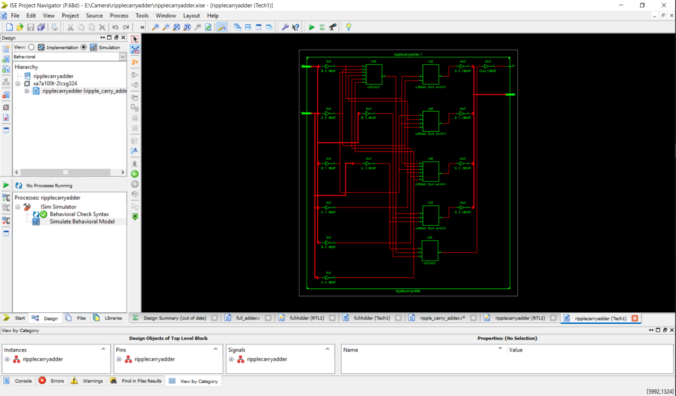

SIMULATION

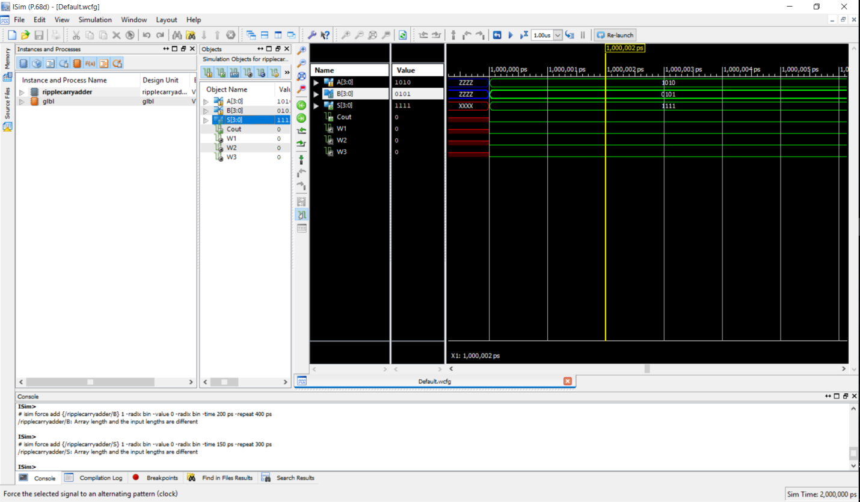

SO HENCE WE HAVE LEARNED HOW TO SIMULATE RIPPLE CARRY ADDER IN XILIN SOFTWARE